Figures2:Figure2_Curcumin_Subgroup Funnel plot
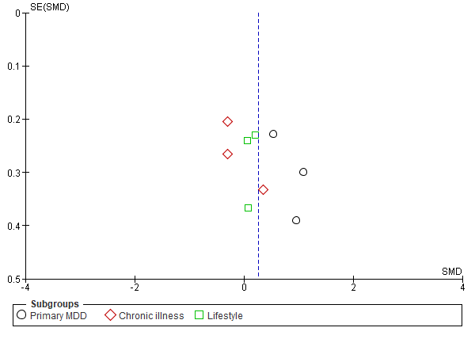
Caption: Figure 2 (Analysis 1.1)
Funnel plot of comparison: 1 Curcumin VS Control, outcome: 1.2 Curcumin VS Control.

